How to configure a laptop running Windows XP for use on the IT managed wireless network

Wireless Requirements:
- Wireless 802.11b card – for this configuration we used the Cisco AIR-PCM350 Series PCMCIA wireless card, however any 802.11b WI-FI card will work on our network but may require additional attention
- Laptop running Windows XP with a free Type II or Type III card slot (usually located on the side of the computer also known as PCMCIA slot).

- Turn off your laptop computer.
- Insert the PCMCIA card into open Type II or III slot on your laptop.
- Turn your laptop back on. When Windows boots up your PC card should already be recognized by Windows. To check go to the Control Panel on your computer, click on Network Connections and you should see Wireless Network Connection listed under the LAN or HIGH-SPEED INTERNET section. Click on Wireless Network Connection X
- 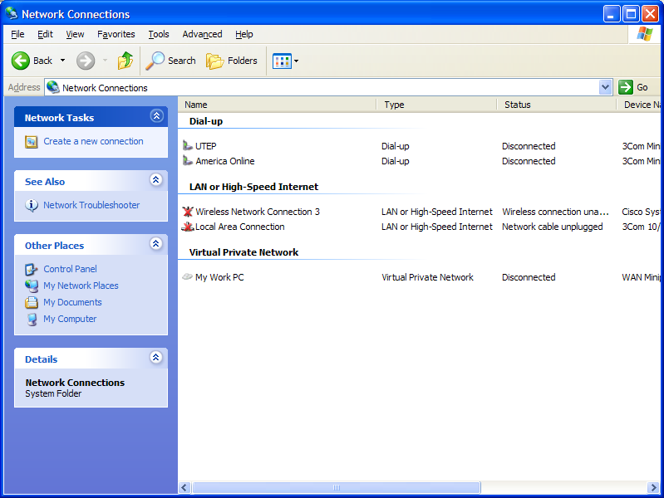
A dialog box should appear, click on the Advanced button, then when the dialogue box appears click on Add
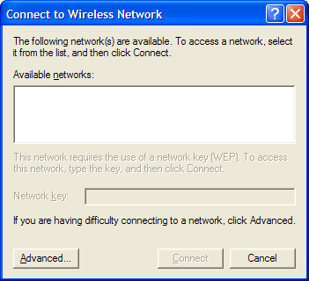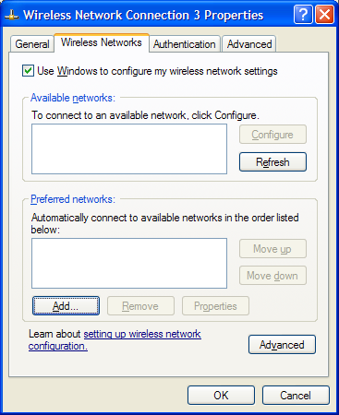

- Enter utepwl1 (case sensitive) as your Network name and click OK.
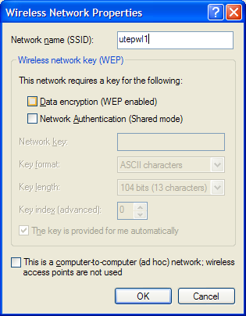

- Click on the Advanced tab in the Wireless Connection Properties window.

- In the Windows Firewall window, Click the Advanced tab.

- Under the ICMP section, Click on the Settings button.

- In the ICMP settings window, Put a check mark in the option that states “Allow incoming echo request”

- Click Ok for all open windows. You are now complete.

